Linear Algebra

Laboratory Activity No. 6

Matrices

|  |  |
| --- | --- |
| *Submitted by:* | *Instructor:* |
| Gatchalian Paulo Valentin M. | Engr. Dylan Josh D. Lopez |

April, 09, 2021

# Objectives

This laboratory activity aims to give knowledge to the student to be familiarized with matrices and their relation into different kinds of equations and as well as to perform basic matrix operation using python programming.

# Methods

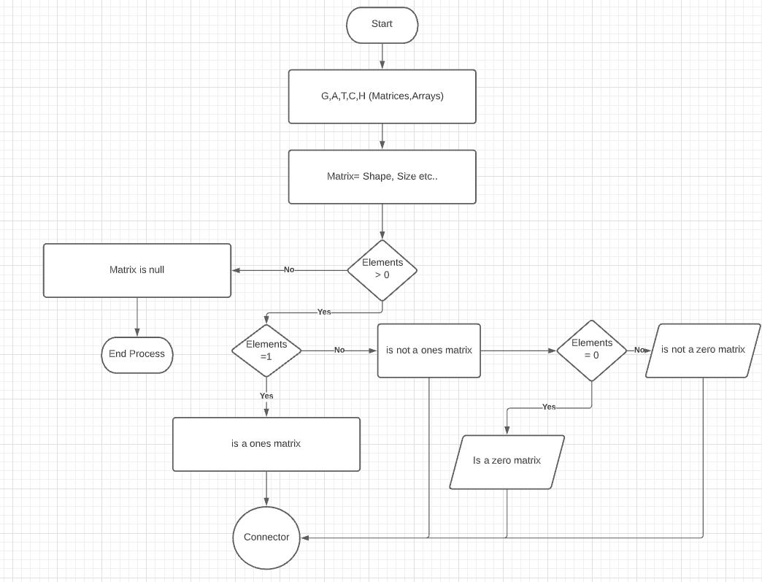

Figure 1: Flowchart for task 1 part 1

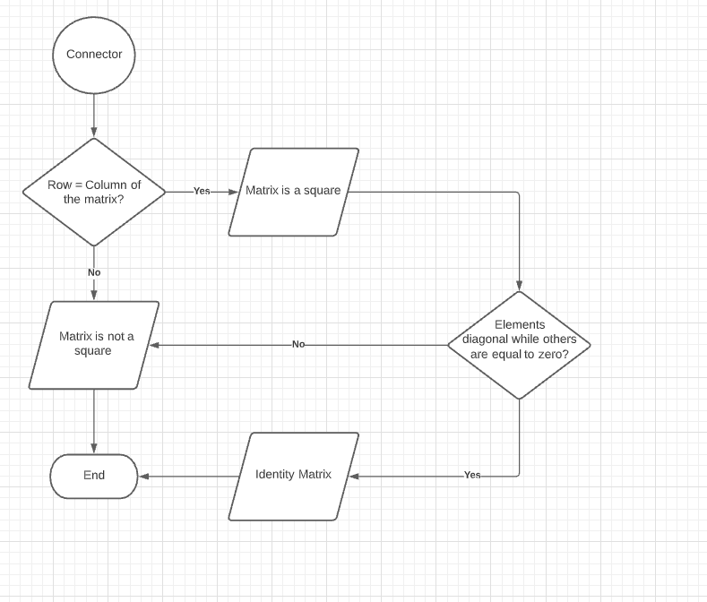

Figure 2: Flowchart task 1 part 2

Given in the figure above represents the flowchart that describes the process of the code and how the code works and the steps in order to present the final output. First, elements are define inside the matrices, and the codes for their respective sizes, shapes, ranks if it is equals to zero. Also seen above is an example elements that are less than “>” or equal to zero “0” inside the decision shape which represents the triangle and will continue to the next decision making if the Matrix is Null and then it will erminate or end the loop of the program.

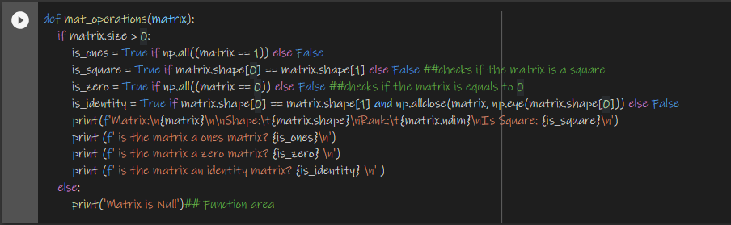

Figure 3: Codes used in task 1

Figure 3 represents the codes that are used to call the function mat_operations which examines all the elements of the matrix that are greater than 0, if it is not equal to 0 but equal to 1, is it a square or is it an identity matrix. Also given in the codes in the figure examines the sizes, ranks, shapes of the matrix that will be further used throughout the process.

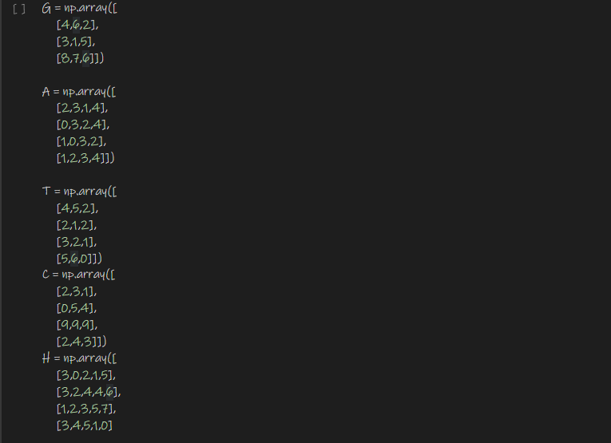

Figure 4: Declaration of Matrices

Figure 4 shows the codes to declare the matrices such as its values the usage of its function, also seen in the codes are use of numpy as np.

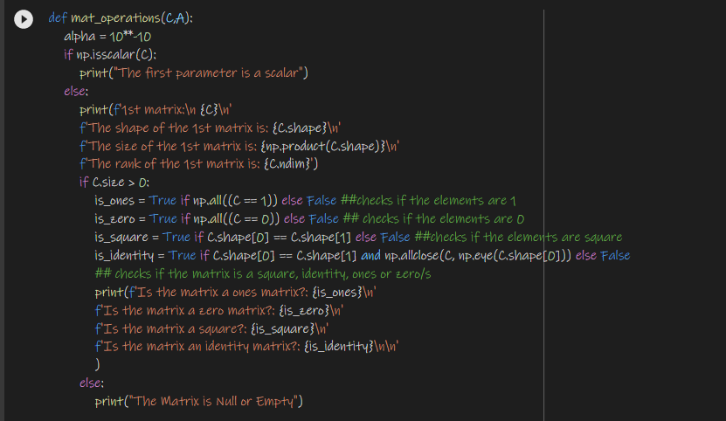

Figure 5: Codes used for task 2 part 1

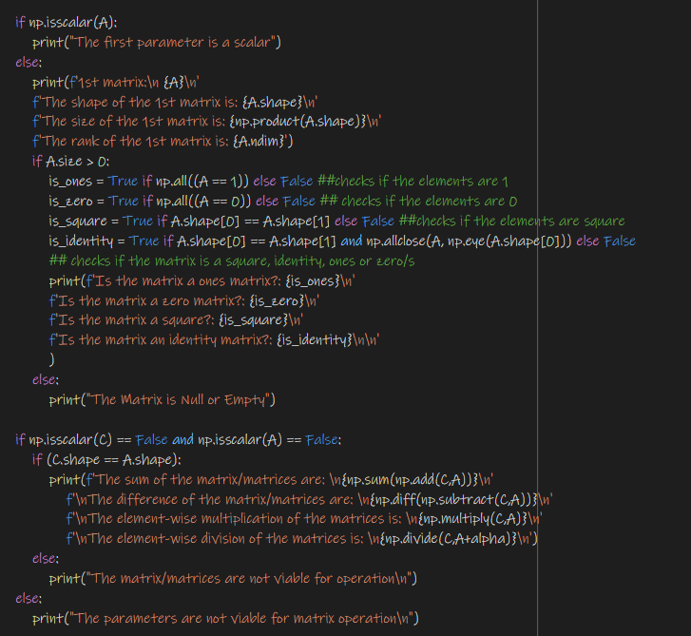

Figure 6: Codes used for task 2 part 2

Figures 5 and 6 are the codes that the student used in order to execute the program that are given in Task 2. Alpha is used for the division process due to the fact that it asks if the matrix is a scalar or non-scalar, then after that the programs asks for the size,shape, etc. just like what happened in task 1 it asks so that it can identify if the matrix is an identity, is it a square or a zero matrix, which the results will be further discuss throughout the process.

# Results

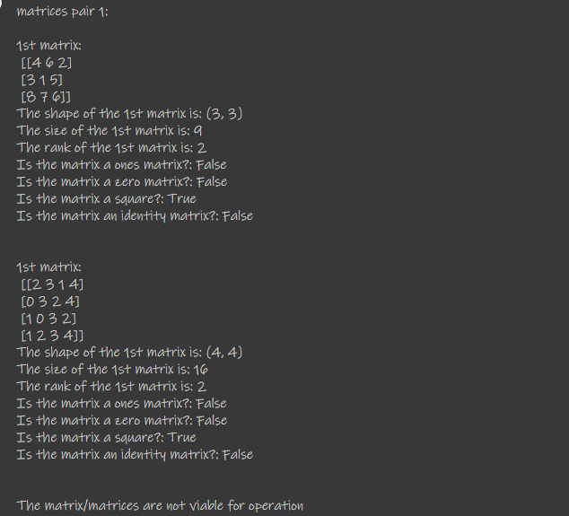

Figure 7: Result of Task 2 part 1 and Task 2 part 2

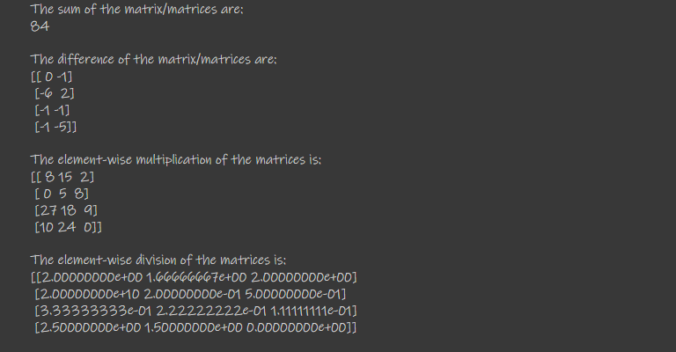

Figure 8: Result of Task 2 part 3

Given in the figures above represents the results of the given codes in the methodology, the student was able to execute the program successfully hence there were problems during the process of making the code. The figures represents he different kinds of outputs such as the The sum and difference of he matrices and as well as the element wise multiplication of the matrices etc. The student was able to iniate and thoroughly presented each methods and result.

# Conclusion

In conclusion to the Laboratory activity, it helped the knowledge and widens the ideas of the students perspective in doing matrices through the use of python programming, Different kinds of outputs, methods and results have been presented during the process of doing the Laboratory activities. The Activity enhanced the knowledge of the student about matrices that can further help him/her in the future.

**References**

[1] D.J.D. Lopez. “Adamson University Computer Engineering Department Honor Code,” AdU-CpE Departmental Policies, 2020.